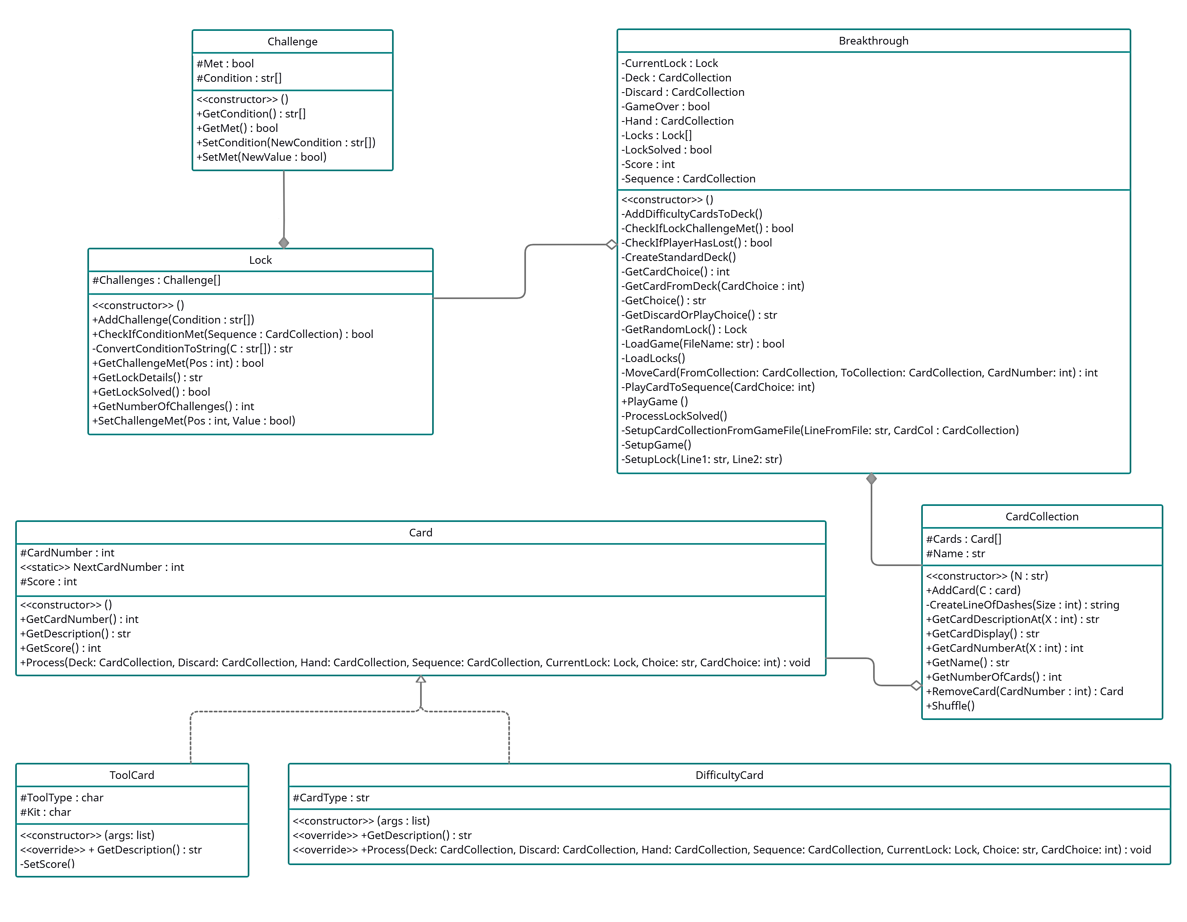

BREAKTHROUGH!

**UML Class Diagram**